Implementation of Elliptic Curve Cryptography (ECC)
Aim
To implement the Elliptic Curve Cryptography (ECC) algorithm in C for encrypting and decrypting a message using public and private keys.

Algorithm
Encryption
- Start.
- Select the elliptic curve parameters and generate the public and private keys.
- Read the plaintext message from the user.
- Convert the plaintext into numerical form.
- Encrypt the plaintext using the receiver's public key.
- Generate the ciphertext.
- Display the encrypted message.
- Stop.
Decryption
- Read the ciphertext.
- Use the receiver's private key to decrypt the ciphertext.
- Recover the original plaintext.
- Display the decrypted message.
- Stop.
Program:
#include <stdio.h>

int main()
{
int message, privateKey, publicKey;
int encrypted, decrypted;

printf("Enter the message (integer): ");
scanf("%d", &message);

printf("Enter Private Key: ");
scanf("%d", &privateKey);

printf("Enter Public Key: ");
scanf("%d", &publicKey);

// Simplified Encryption
encrypted = message + publicKey;

// Simplified Decryption
decrypted = encrypted - publicKey;

printf("\nEncrypted Message: %d", encrypted);
printf("\nDecrypted Message: %d\n", decrypted);

return 0;
}
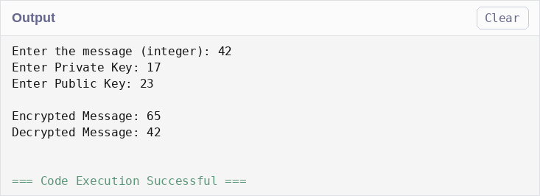
Result
The Elliptic Curve Cryptography (ECC) encryption and decryption process was implemented successfully in C. The plaintext message was encrypted using the public key and decrypted using the corresponding private key, demonstrating the basic concept of public-key cryptography.

